
SAFEGUARDING
If you have a concern that a child has been harmed, or is at risk of harm, or you receive a disclosure, you must contact the office immediately and ask to speak to a member of our Safeguarding Team:
Mrs S. Coates, Mrs R. Bergamino, Mrs H. Temple and Miss L. Hurndall


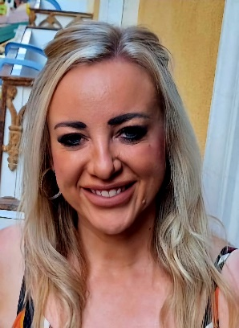
Mrs R. Bergamino
Headteacher
Deputy Designated Safeguarding Lead

Mrs S. Coates
Assistant Headteacher
Designated Safeguarding Lead


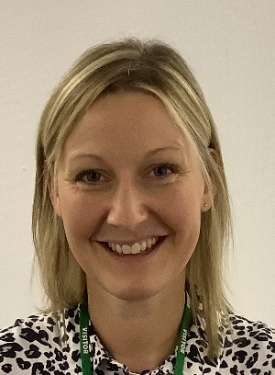
Mrs H. Temple
Assistant Headteacher
Deputy Designated Safeguarding Lead
Miss L. Hurndall
EYFS Phase Lead
Deputy Designated Safeguarding Lead

