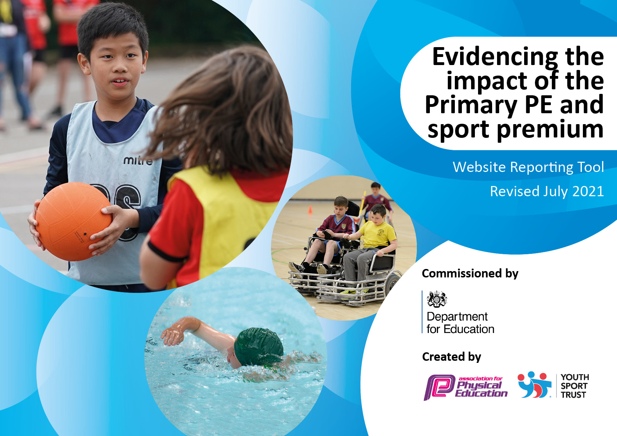
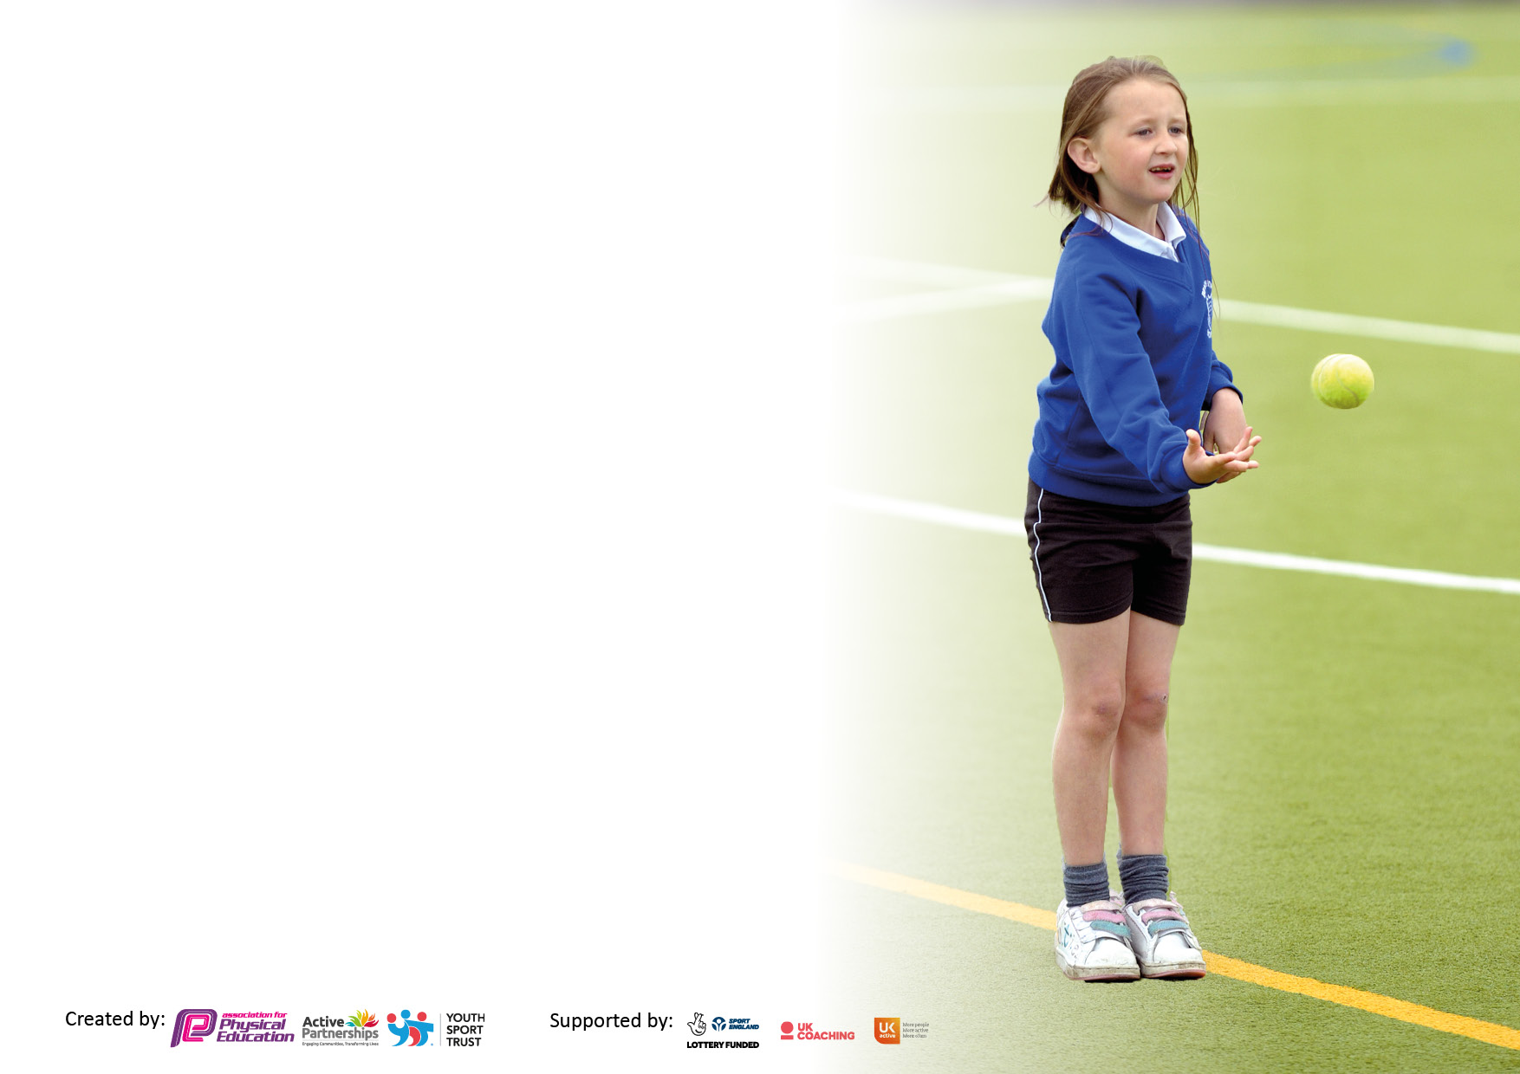
It is important that your grant is used effectively and based on school need. The Education Inspection Framework makes clear there will be a focus on ‘whether leaders and those responsible for governors all understand their respective roles and perform these in a way that enhances the effectiveness of the school’.

Under the Quality of Education Ofsted inspectors consider:
Intent - Curriculum design, coverage and appropriateness
Implementation - Curriculum delivery, Teaching (pedagogy) and Assessment
Impact - Attainment and progress

To assist schools with common transferable language this template has been developed to utilise the same three headings which should make your plans easily transferable between working documents.

Schools must use the funding to make additional and sustainable improvements to the quality of Physical Education, School Sport and Physical Activity (PESSPA) they offer. This means that you should use the Primary PE and sport premium to:

- Develop or add to the PESSPA activities that your school already offer
- Build capacity and capability within the school to ensure that improvements made now will benefit pupils joining the school in future years
- The Primary PE and sport premium should not be used to fund capital spend projects; the school’s budget should fund these.

Please visit gov.uk for the revised DfE guidance including the5 key indicators across which schools should demonstrate an improvement. This document will help you to review your provision and to report your spend. DfE encourages schools to use this template as an effective way of meeting the reporting requirements of the Primary PE and sport premium.

We recommend you start by reflecting on the impact of current provision and reviewing the previous spend.

Schools are required to publish details of how they spend this funding, including any under-spend from 2019/2020, as well as on the impact it has on pupils’ PE and sport participation and attainment. All funding must be spent by 31st July 2022.

We recommend regularly updating the table and publishing it on your website throughout the year. This evidences your ongoing self-evaluation of how you are using the funding to secure maximum, sustainable impact. Final copy must be posted on your website by the end of the academic year and no later than the 31st July 2021. To see an example of how to complete the table please click HERE
Details with regard to funding
Please complete the table below.

Total amount allocated for 2022/23 | £18,750
Swimming Data
Please report on your Swimming Data below.
Meeting national curriculum requirements for swimming and water safety.

N.B Complete this section to your best ability. For example you might have practised safe self-rescue techniques on dry land which you can transfer to the pool when school swimming restarts.
Due to exceptional circumstances priority should be given to ensuring that pupils can perform safe self rescue even
if they do not fully meet the first two requirements of the NC programme of study.
What percentage of your current Year 6 cohort swim competently, confidently and proficiently over a distance of at least 25 metres?  N.B. Even though your pupils may swim in another year please report on their attainment on leaving primary school at the end of the summer term 2021.  Please see note above. | 65
What percentage of your current Year 6 cohort use a range of strokes effectively [for example, front crawl, backstroke and breaststroke]?  Please see note above. | 75
What percentage of your current Year 6 cohort perform safe self-rescue in different water-based situations? | 100%
Schools can choose to use the Primary PE and sport premium to provide additional provision for swimming but this must be for activity over and above the national curriculum requirements. Have you used it in this way? | Yes

Action Plan and Budget Tracking
Capture your intended annual spend against the 5 key indicators. Clarify the success criteria and evidence of impact that you intend to measure to evaluate for pupils today and for the future.

Academic Year: 2022/23 | Total fund allocated: £18,390 | Date Updated: 1/9/22
Key indicator 1: The engagement of all pupils in regular physical activity – Chief Medical Officers guidelines recommend that primary school pupils undertake at least 30 minutes of physical activity a day in school |  |  |  | Percentage of total allocation:
 |  |  |  | %
Intent | Implementation |  | Impact
Your school focus should be clear what you want the pupils to know and be able to do and about  what they need to learn and to  consolidate through practice: | Make sure your actions to achieve are linked to your intentions: | Funding allocated: | Evidence of impact: what do pupils now know and what can they now do? What has changed?: | Sustainability and suggested next steps:
Ensure children are physically active at break and lunch time. | Break and lunch clubs will be ran by playground leaders and Mr Collantine, to ensure children are physically active. | Equipment £500  Mr Collantine (£4197) | Children will improve their basic fundamental movement skills.  This supports children to hit their recommend 30 minutes of active a day in school.  Children who participate will understand how they can be physical active for short bursts. | Playground leaders will improve their ability to coach and communicate with others.  Playground leaders and Mr Collantine will upskill next years playground leaders.  Promoting physical active at break and lunch.
Children to become more physically active during lessons. | Children’s activity levels will increase in the classroom by participating in a short burst of activity, delivered by teachers and Mr Collantine. |  | Children participate in activity during classroom time, to support the 30 active minutes.  Children’s physically activity levels increase. | Physical activity exercise training will be delivered to staff to upskill their knowledge, to create their own plans to implement activity in the classroom.
Improve active travel. | Children in Year 5 and 6 will complete cycling proficiency, to enable them to have the skills and confidence to ride their bike to and from school safely.  Mr Collantine to deliver after school clubs for scootering and balance bikes, to support children to be confident and safe when using them.  Mr Collantine will complete surveys to track active travel.  Letters will go out to parents throughout the year to encourage active travel. | Part of the RESSP buy in (£4500). | Children’s physical activity level will increase.  Children will display confidence and safety when using bikes and scooters.  Active travel will improve due to the competency and confidence of the children. | This is a sustained way of keeping children active during travel.
Key indicator 2: The profile of PESSPA being raised across the school as a tool for whole school improvement |  |  |  | Percentage of total allocation:
 |  |  |  | %
Intent | Implementation |  | Impact
Your school focus should be clear what you want the pupils to know and be able to do and about  what they need to learn and to  consolidate through practice: | Make sure your actions to achieve are linked to your intentions: | Funding allocated: | Evidence of impact: what do pupils now know and what can they now do? What has changed?: | Sustainability and suggested next steps:
Further develop the impact of leaders in lesson, Playground Leaders and the Sports Ambassadors. | Playground leaders and Sports Ambassadors will lead activities at lunch.  Children will lead a warm up and main activity in P.E.  The leaders will also support events ran by RESSP.  All playground leaders to have the opportunity to deliver an after school club. | Leadership training cost: Part of the RESSP buy in (part of £4500)  Playground leader equipment: £150 | Pupils become more confident in their own leadership capabilities.  Pupils develop their knowledge of how they can help others become more physically active.  School becomes more active as a whole due to playground leaders gaining confidence and knowledge. | Children will have the knowledge to support younger pupils to improve their leadership skills.  Children will have the skills to deliver their own lunch clubs without Mr Collantine’s support.
Develop pupils’ strength and core stability. | To deliver high quality strength and core stability exercises in PE.  Playground leaders to deliver strength exercises during lunch activities. | Equipment: £100 | Pupils will show an improvement in their gross/ fine motor skills, which will help their control of their body when in the classroom.  This will help improve posture and handwriting. | All children will gain knowledge of strength and core exercises.

Key indicator 3: Increased confidence, knowledge and skills of all staff in teaching PE and sport |  |  |  | Percentage of total allocation:
 |  |  |  | %
Intent | Implementation |  | Impact | 35%
Your school focus should be clear | Make sure your actions to | Funding | Evidence of impact: what do | Sustainability and suggested
what you want the pupils to know | achieve are linked to your | allocated: | pupils now know and what | next steps:
and be able to do and about | intentions: |  | can they now do? What has
what they need to learn and to |  |  | changed?:
consolidate through practice:
Up-skill teachers and their knowledge in PE. | Mr Collantine to deliver training to staff members on a 1-2-1 basis or as groups to up-skill their knowledge of fundamental movements skills and the impact they can have on the whole school improvement.  Mr Collantine to do his own personal develop to further develop his knowledge and attend training courses. | Mr Collantine (apart of salary £150) | Teachers will have an increased confidence and understanding of the P.E curriculum and how the importance of physical activity. | Teachers are capable of teaching P.E when they need to.
Key indicator 4: Broader experience of a range of sports and activities offered to all pupils |  |  |  | Percentage of total allocation:
 |  |  |  | %
Intent | Implementation |  | Impact | 6%
Your school focus should be clear | Make sure your actions to | Funding | Evidence of impact: what do | Sustainability and suggested
what you want the pupils to know | achieve are linked to your | allocated: | pupils now know and what | next steps:
and be able to do and about | intentions: |  | can they now do? What has
what they need to learn and to |  |  | changed?:
consolidate through practice:
Ensure all children enjoy being physical active. | PE and after school clubs will be inclusive to all, focusing on fundamental movement skills to improve children’s confidence, motivation and competence. | £200 for equipment  Mr Collantine (£3358) | Children’s confidence and motivation will improve as they will feel more physically competent to participate. | Children’s enjoyment will improve increasing the chance of sustained physical activity in and out of school.
Introduce new activities to the curriculum and after school clubs. | New sports and activities will be introduced to the PE curriculum and after school clubs improving inclusivity and variety of how the fundamental movement skills are developed, giving greater depth. | Mr Collantine (£3358) | Children have a broader experience of different ways they can be physically active.  This will improve after school club participation rate and will result in children becoming more physically active.  Children’s confidence and competence in PE will improve. | Children will be competent and have the confidence to join outside of school club activities.
Key indicator 5: Increased participation in competitive sport |  |  |  | Percentage of total allocation:
 |  |  |  | %
Intent | Implementation |  | Impact | 12%
Your school focus should be clear | Make sure your actions to | Funding | Evidence of impact: what do | Sustainability and suggested
what you want the pupils to know | achieve are linked to your | allocated: | pupils now know and what | next steps:
and be able to do and about | intentions: |  | can they now do? What has
what they need to learn and to |  |  | changed?:
consolidate through practice:
Ensure every pupil participates in a competition or a festival. | Use the participation tracker to track which pupils have attended a competition or festival.  Enter into the RESSP competitions and festivals.  Ensure children are entered into the appropriate level of competition to suit their motivation, competence and confidence. | Competition and festival cost: Part of the RESSP buy in (£4500).  Transport (£1500) | Pupil’s will gain experience competing against other pupils from the area.  Pupils’ will develop their skill, knowledge and confidence from attending a competition or a festival.  100% of children will have attended a competition or festival.  Pupils’ will represent the school and have a feeling of pride. | Ensure all children are appropriately prepared for the competition they are attending to ensure maximum benefit.  Promote team work and competition in P.E to ensure children are familiar with them both.
Increase competitive sport in school. | P.E. lessons will involve competitive games both as a team and an individual. | Trophies/ medals: £300 | Children will gain experience in competing against themselves and improving their personal best.  Children will improve their team work, communication and conflict resolution skills by competing against each other in P.E and after school clubs.  Children will have increased confidence when competing against other schools at competitions. | Children will have a good understand of competing against others and themselves, when they get into KS2 ready for competitions.

Signed off by
Head Teacher: | Sarah Hill
Date:
Subject Leader: | Mr Collantine
Date: | 12.9.22
Governor:
Date:

